WARNING: MISBEHAVIOR AT EXAM TIME WILL LEAD TO SERIOUS CONSEQUENCE.
Name Student ID
School Major/Class Seat No.
( DONNOT WRITE YOUR ANSWER IN THIS AREA )
……………………………………………………Seal Line………………………………………………Seal Line………………………………………Seal Line……………………………………线………………………………………

SCUT Final Exam
Mathematical Analysis I Exam Paper A（2019-2020-1）
Notice: 1. Make sure that you have filled the form on the left side of seal line.

2. Write your answers on the exam paper.
3. This is a close-book exam.
4. The exam with full score of 100 points lasts 120 minutes.

Question No. | I | II | III | IV | Sum
Score
Score

- Please fill the correct answers in the following blanks. (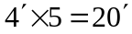)
1.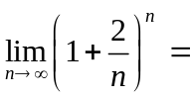 .
2. If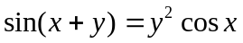, then 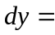 .
3. The inflection points of the curve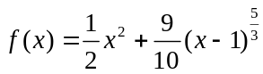are .
4. Supposeis continuous with the property that 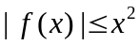for all, then 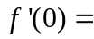 .
5. If is continuous, and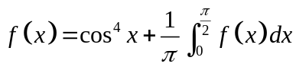, then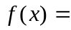 .

II. Finish the following calculations. (6-11: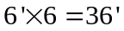)
Score

6. 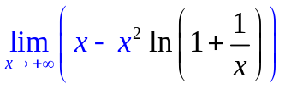.

7. 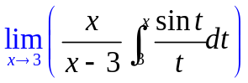

8. If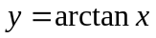, find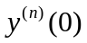.

9. Evaluate the indefinite integral 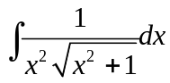

10. (a) Find the tangent to the cycloid 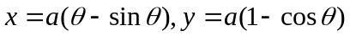 ( is a constant) at the point where 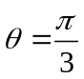.
(b) Find the area under one arch of the cycloid.

III．Prove the following conclusions. (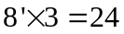 )
Score

11. Prove that 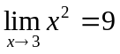 by using the 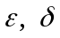 definition of limit.

12. Let 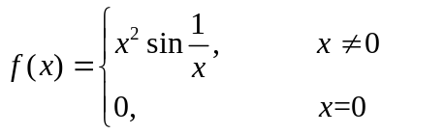.
Find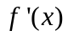. Iscontinuous at？Show your reasons.

13. Assume thatis continuous on the closed interval, andis differentiable in the open interval ,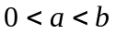. Use Cauchy’s mean value theorem to prove that there exists 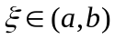 such that
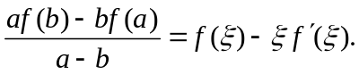

Score

IV．Finish the following questions. (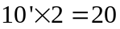 )

14. Find the volume of the solid obtained by rotating about the region between  and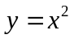.

15. A sequence 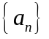is given by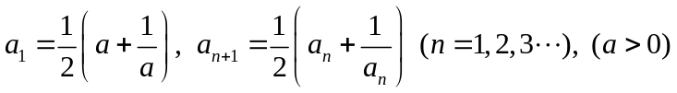. Show that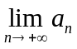exists and find it.

